NOTE: Gonads are the organs that produce the gametes. The male gonad is the testes while the female gonad is the Ovary.
STRUCTURE OF THE MAMMALIAN GAMETE
A gamete is a mature sexual reproductive cell having a single set of unpaired chromosomes. They are formed in the gonads (testis or ovaries) through a process called gametogenesis.
Male Gamete
The male gamete is called sperm (or spermatozoa) and is produced in the testes by a processed called spermatogenesis. It is microscopic and unicellular. Usually smaller and more elongated than the egg; about 0.05mm long.
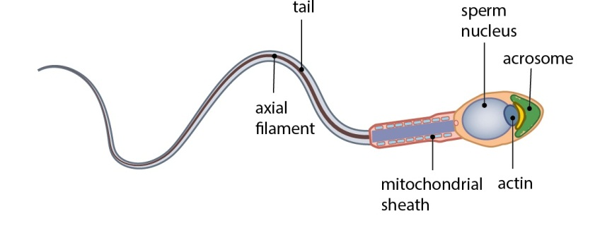
A Spermatozoon cell ( The male gamete)
Structure Of The Spermatozoon
i. Acrosome: It can be found at the upper part of the head, containing lytic enzymes used to dissolve egg membrane to enhance penetration during fertilization.
ii. Nucleus: Located in the head, it contains the father’s genetic material.
iii. Mitochondria: Located in the middle piece, these organelles produce ATP (energy) to power the tail movement.
iv)Flagellum: The long whip-like tail for propelling the sperm cell.
Female Gamete
The female gamete is called egg (ovum) and is produced in the ovary by a processing called oogenesis. This is larger than sperm, about 0.1mm in diameter.
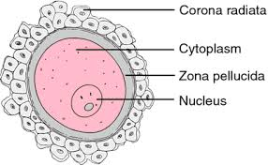The female gamete (ova)

Structure of the Female gamete
i. A central Nucleus: It contains the chromosomes which carry the genes.
ii. Granules and yolk droplets: A source of nourishment for the embryo at the early stage of development
iii. Plasma membrane: It surrounds the cytoplasm
NOTE: The nuclei of the sperm and ovum contains chromosome which carries the genes that are responsible for transmission of characters from parents to offsprings.
Differences Between The Male And Female Reproductive Gametes
MALE (SPERMS) | FEMALE (EGGS)
It is motile | It is not motile
Food reserve/ yolk is absent | Yolk is present
It is not visible to the naked eyes | It is visible to the naked eye
It has smaller cytoplasm | It has large cytoplasm

REPRODUCTIVE SYSTEM IN FLOWERING PLANTS
NEW TOPIC
The flower is the major reproductive organ of the flowering plant (Angiosperm). Flowers exist in different sizes, shapes, colours and patterns of arrangements. A flower is a cluster of modified leaves carried on a reduced stem called flower stalk or pedicel. The flower is made up of four floral parts (whorls). These are;
- Calyx (Sepals) (ii) Corolla (Petals) (iii) Androecium (Stamen) (iv) Gynoecium (Carpel)
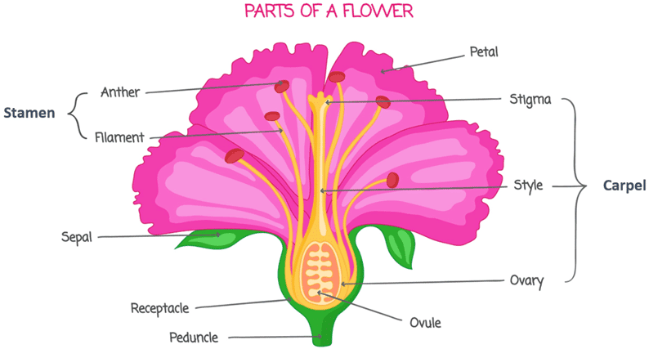
The structures and their functions are as listed below:
i. Calyx (Sepals): This makes up the outermost whorl consisting of leaf-like structures called sepals which are fixed to the receptacles. Sepals protect the flower during the bud stage. They are mostly greenish are also photosynthetic. Some sepals are brightly coloured and look like petals (petaloids). Sepals: may be separated (polysepalous) as in Pride of Barbados. Others are fused or partly joined together to form a cup-like structure (gamosepalous) as seen in the hibiscus.
ii. Corolla (Petals): these are large brightly coloured modified leaf like structure called petals. They arise within the calyx. Petals are usually brightly coloured or scented thereby attracting pollinators. Petals could be separated as in Hibiscus and Pride of Barbados (Polypetalous) or fused to form a tube are in Allamanda and Milk Bush (Gamopetalous). Petals also serve to protect the stamen and the carpals. In a few cases, petals appear greenish (Perianth).
iii. Androecium (stamens): this is the third whorl and it is the male reproductive organ of the flower. It consists of individual units called stamens. Each stamen is made up of two parts;
- Filaments: a slender stalk that supports the anther
- Anther: a lobe-like or swollen structure at the top of the filament that contain pollen sacs, These sacs produce pollen grains (the male gamete)
The androecium produces pollen grains necessary for fertilization
iv.Gynoecium / Pistil (Carpel): this is the female reproductive organ of the flower. It is the innermost whorl of the floral parts of a flower. It consists of one or more carpel(s) also known as the pistil. The carpel is made up of three parts, namely:
- Stigma: the sticky top surface which receives the pollen grains during pollination.
- Style: this is the tube that join the stigma to the ovary
- Ovary: this contains the ovules which form fertile seeds after fertilization. Depending on its position, a flower can be classified as Hyogynous (superior ovary), Epigynous (Inferior ovary), and Perigynous (half inferior ovary).
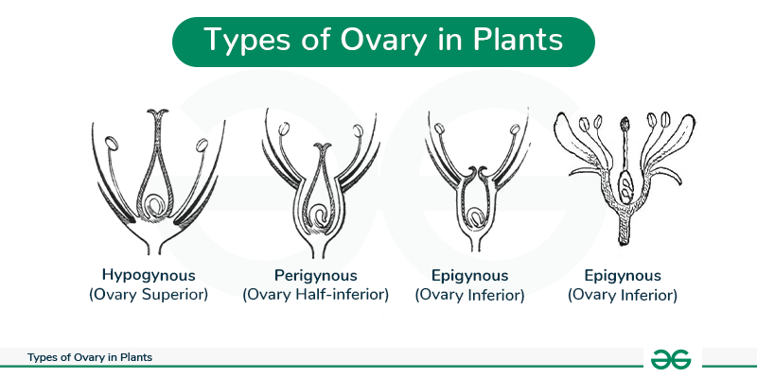
Types of Pistil
- Monocarpous pistil (having a single carpel e.g., flamboyant)
- Apocarpous pistil (having two or more separate carpels e.g., Rose)
- Syncarpous ( having two or more carpels fused together
Other parts of a flower are;
1. Pedicel: this is the part attaches the entire flower to the stem or branch of the plant. It is also called the flower stalk. It is described as a reduced stem bearing the parts of the flower (modified leaves).
2. Receptacle: this is the enlarged end of the pedicle to which all the other floral parts are attached. It also encloses the ovary
NOTE: The Androecium and Gynoecium are referred to as the Essential Parts of the flower because they produce the reproductive cells while the Calyx and Corrolla are regarded as Non-Essential parts of the flower because they are not involved in gamete production.

TYPE OF FLOWERS
Flowers are classified into various types based on the following;
- Based On Floral Parts
- Complete Flowers: Contain all four main floral whorls: sepals, petals, stamens (male), and carpels/pistils (female) examples include; Hibiscus, roses, lily
- Incomplete Flowers: Lack one or more of the four main floral parts e.g.,Pawpaw, maize, and willow flowers
- Based on Reproductive Organs
- Bisexual (Perfect) Flowers: Contain both male (stamens) and female (carpels) reproductive organs in the same flower e.g., Hibiscus, pride of Barbados
Unisexual (Imperfect) Flowers: Contain either only male parts or only female parts. E.g., maize tassel, pawpaw).
- Based on Ovary Position
- Hypogynous (Superior Ovary): The ovary is situated at the highest point on the receptacle, with other floral parts (sepals, petals, stamens) attached below
- Perigynous (Half-Inferior): The receptacle forms a cup, and the other parts are attached around the ovary.
- Epigynous (Inferior Ovary): The receptacle grows around the ovary, fusing with it, making other floral parts appear to grow from the top of the ovary.
NOTE: After fertilization, the ovary develops into a fruit, whereas the ovules in most flowers develop into seeds.

PLANCENTATION
The arrangement of ovules within the ovary is called plancentation. Plancentations are of various types i.e.
1. Axile: The ovule s here are attached to the centre of the ovary e.g. Tomato and cannas lily.
2. Marginal: The ovules are attached along one edge of a monocarpous ovary. E.g. pride of Barbados, flamboyant and crotaria
3. Parietal: The ovules are arranged along many lines on the ovary wall. E.g. pawpaw.
4. Free-central: The ovules are attached to projections from the base of the ovary.
5. Basal: The ovules are attached to the base of the ovary. E.g. sunflower.
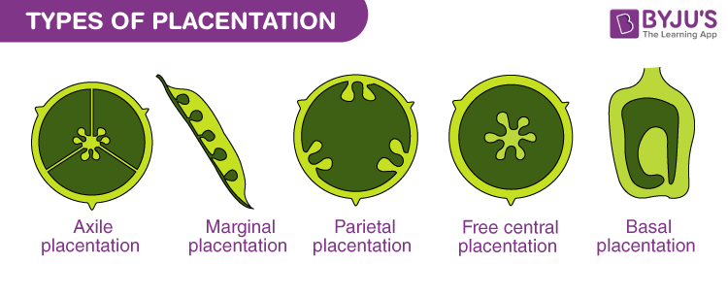

POLLINATION
NEW TOPIC
Pollination is the transfer of pollen grains from an anther of a flower are to the stigma of the same flower or another flower of the same species. Flowers have evolved special structured and mechanisms to ensure successful pollination. This process enables fertilization and sexual reproduction to occur.
TYPES OF POLLINATION
There are two types of pollination:
- Self-pollination: This is the process by which mature pollen grains are transferred from the anthers of a flower to the stigma of the same flower (autogamy) or other flowers on the same plant (cleistogamy). This process has a high successful rate and the offspring show very little genetic variation.
Self-pollination can occur only in bisexual flowers and in unisexual flowers of monoecious plants.

Adaptive Features that Favours Self- Pollination
- Homogamy: This refers to the ripening of the anthers and stigmas of a bisexual flower at the same time.
- Cleistogamy: This occurs among closed bisexual flowers. Because they do not open, this forces the ripe pollen grains to be deposited on the stigma of the same flower.
ii. Cross pollination: this is the transfer of mature pollen grains from the anther of a flower to the stigma of a different flower of another plant of the same or closely related species. This process is risky and wasteful as most pollen grains fail to reach receptive stigma. Cross pollination brings the male and female gametes of two different parent plants together. There are great genetic variations among the offspring which tend to be healthy and well adapted.
Adaptive Features that Favours Cross- Pollination
- Unisexuality: This occurs when female and male flowers are borne on separate plants. (Dioecious plants) such as pawpaw.
- Dichogamy: This is a condition in which the male and female reproductive organs of a flower mature of different times. Self-pollination is usually impossible in this situation.
- Self-incompatibility: The bisexual flowers of some species may bear mature stamens and carpels at the same time. However pollen grains falling on the stigma of the same flower of flower on the same plant fail to fertilise; hence they become sterile e.g. tea and passion flower.

Self-Sterility
This refers to a situation in which some plants make themselves sterile. In self-incompatible plant, Due to the presence of pollen on their stigmas released by the same plant, they make their self sterile.
AGENTS OF POLLINATION
Flowers can be pollinated by insects, wind, water and other animals including man. The two major agents of pollination are Wind and Insects.
Wind Pollinated Flowers
Wind-pollinated flowers are regarded as Anemophilous flowers. Examples are maize, rice, millet, grasses and sugarcane.
Characteristics of Wind Pollinated Flowers
i. The flowers are dull in colour
ii. Scent is absent
iii. Nectar is absent
iv. Large amount of pollen grain is produced
v. They have small and inconspicuous petals/ sepals
Insect Pollinated Flowers
Insect pollinated flowers are also known as Entomophilous flowers. Examples of insect pollinated flowers are cowpea, Hibiscus etc.
i. They have large petals/ sepals
ii. Flowers are brightly coloured
iii. They possess scent
iv. Nectar is present
v. Pollen grains are rough, sticky and relatively few

